**IC-ENC RENC Description Document**

**Purpose of Document**

This document provides a high level description of the operation, governance and finances of the International Centre for Electronic Navigational Charts (IC-ENC). The intended audience is the Hydrographic Office (HO) community, particularly those International Hydrographic Organization (IHO) member states who are not currently a member of a Regional ENC Co-ordinating Centre (RENC).

The format of the document will allow an easy comparison between the different RENC models, and provide clarity to a subject that is acknowledged as complex to those without a detailed knowledge of the RENC organisations.

**What is a RENC?**

RENC stands for Regional ENC Coordinating Centre. A RENC is an organisation, conceptualised in the Worldwide Electronic Navigational Chart Database (WEND) principles of the IHO, through which IHO members can co-operate to resolve overlaps and gaps in coverage, ensure compliance with S-57 and S-63 encoding standards, provide a world-wide consistent level of high quality data and support the provision of co-ordinated end-user services for official ENCs.

The IHO WEND principles encourage Member States to distribute their ENCs through a RENC in order to share in common experience and reduce expenditure, and to ensure the greatest possible standardization, consistency, reliability and availability of ENCs.

**What is IC-ENC?**

IC-ENC is a RENC, and was formed in 2002. It is a low-cost, not-for-profit organisation controlled by its members.

IC-ENC is an association of national hydrographic organisations working together to harmonise the production and distribution of high quality ENCs. The common goal is to promote safe navigation at sea. IC-ENC’s mission is:

To provide services, at a low cost, to national Hydrographic Offices that ensure their ENCs are:

* compliant to the international standards,
* consistent across the global dataset,
* and readily available for use.

This is so that shipping can navigate safely, efficiently and confidently, whilst ensuring other maritime users are using the same approved data.

IC-ENC has four regional offices located in different areas of the world:

* IC-ENC UK (HQ) - based in Taunton, UK with 11 staff
* IC-ENC Australia - based in Wollongong, Australia with 2 staff
* IC-ENC Latin America - based in Niteroi, Brazil with 2 staff (operational 2016)
* IC-ENC North America - based in Washington, USA with 2 staff (operational 2016)

​​​​

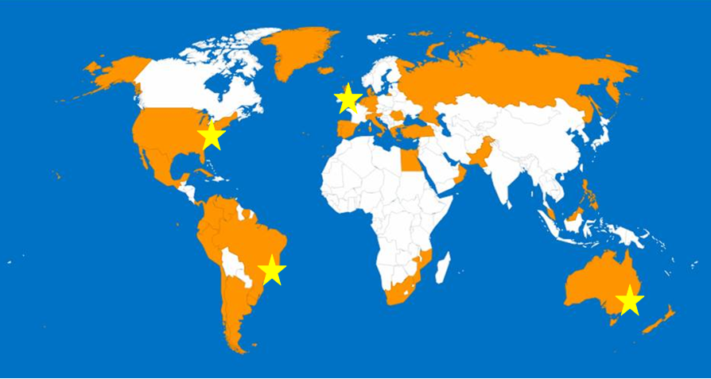

*Location Map of IC-ENC Offices*

IC-ENC provides an independent ENC quality assurance service and supply path to market for its members’ data. The validation feedback provided by IC-ENC is aimed at improving the individual ENC, improving consistency across the entire dataset, and improving the usability of the product. At all times the feedback is targeted advice designed to improve the product to the benefit of the mariner.

The IC-ENC business model allows for regional offices to operate to the same standards as the main office in England. IC-ENC developed the concept to create regional centres that manage:

* Validation of national or regional data
* Regional cooperation on ENC production
* Development of regional views on standardisation rules and representation of these at IC-ENC working groups

The regional office model promotes consistency, efficiency and partnership within the region and fits neatly into the WEND concept. IC-ENC encourages the development of regional offices and provides support and training as required.

In January 2005, Australia launched the second regional coordinating centre within the IC-ENC family. Hosted by the Australian Hydrographic Service (AHS), this office provides the same comprehensive and independent quality assurance services undertaken by the main IC-ENC office in Taunton. More recently, IC-ENC confirmed the development of two further offices, IC-ENC Latin America and IC-ENC North America. These two offices are currently under development, and will be launched in 2016.

When the ENCs have been validated and are ready for distribution, IC-ENC delivers each ENC file to its Value Added Resellers (VARs) as a complete Exchange Set. The VARs are companies that have practical experience in digital chart supply, and who are able to offer comprehensive ENC services for the mariner. By working with these assessed vendors, IC-ENC ensures the mariner has a choice between different styles of services each incorporating the wide range of ENCs, which are available through well-known international distribution outlets.

IC-ENC members therefore benefit from being part of a centre of expertise that provides cost effective quality assurance, advice, distribution, and revenue management services.

IC-ENC’s structure is presented below:

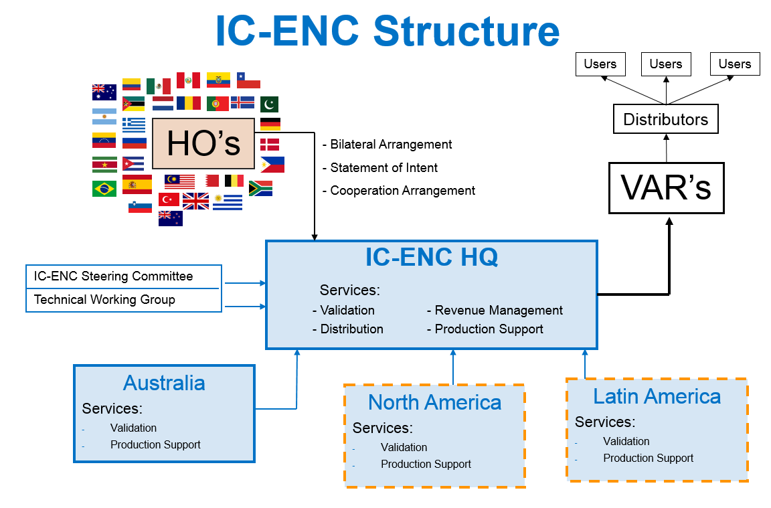

**Who are the current members of IC-ENC?**

Together, and with the support of IC-ENC, the following 38 nations are producing and maintaining a sizeable ENC dataset, currently made up of approximately 5,700 ENC base cells and growing each week.

|  |  |  |
| --- | --- | --- |
| **​​Argen​tina​** | **​Australia** | **​Bahrain** |
| **​Belgium** | **​Brazil** | **​Chile** |
| **​Columbia** | **​Cuba** | **​Denmark** |
| **​Ecuador** | **​Egypt** | **​Germany** |
| **​Greece** | **​​Iceland** | **​Italy** |
| **​Israel** | **​Malaysia** | **​Mexico** |
| **​Mozambique** | **​Netherlands** | **​New Zealand** |
| **​Oman** | **​Pakistan** | **​Panama** |
| **​Peru** | **​Philippines** | **​Portugal** |
| **​Romania** | **​Russia** | **​Slovenia** |
| **​South Africa** | **​Spain** | **​Suriname** |
| **​Turkey** | **​United Kingdom** | **United States\*** |
| **Uruguay** | **Venezuela** |  |

*IC-ENC membership pending

The size of the IC-ENC membership has grown steadily since formation, and IC-ENC welcomes new members.

**What services and benefits do IC-ENC members get?**

**Independent ENC Validation**

The ENC standards are complex and at times open to interpretation. This has led to various ENC production software systems, HO production teams, and ECDIS systems each handling ENCs slightly differently. IC-ENC therefore conducts a full and independent quality assurance of all of the ENC files it receives.

It is the quality and consistency of the whole database which is important to the navigator, and for stable ECDIS operation. IC-ENC members therefore recognise that a consistent approach to validation is crucial, and this requires a central independent function.

IC-ENC is an ENC centre of expertise, with an experienced staff that has seen many different flavours and styles of ENCs. The IC-ENC team operates to validation policies which are based fundamentally on improving the ENC database for the mariner, rather than simply conforming to the standards. As such, IC-ENC’s feedback reports go beyond the single ENC file, reporting on wider data consistency and usability issues. The assessment is made with the use of commercial validation software (7Cs ENC Analyzer and Designer, dKart Inspector), in-house software, and due to the need for install logs, at least one well known and widely used ECDIS system.

IC-ENC members receive a comprehensive feedback report for each processed ENC file, allowing the HO to easily focus on the issues that merit their further attention.

The IC-ENC Validation service is described comprehensively in the Validation Description supporting document. This can be found on our website [www.ic-enc.org](http://www.ic-enc.org).

**ENC Production Support**

IC-ENC assists members with ENC production concerns, through email, phone calls and face-to-face technical support visits. This can range from initial advice on ENC production, chart schemas and internal validation routines for those members commencing their production, to detailed responses on specific technical encoding issues for the more established ENC production departments.

The validation tools are complex, ambiguous and can often report erroneously. IC-ENC members have full access to the *IC-ENC Errors Database*, a database of validation tool error messages, explaining their meaning, significance and action to take, to help support their own production and validation work. The IC-ENC team keeps this database updated as its gains further experience from seeing more ENCs from a growing number of countries, and based on feedback it receives from other users of the same software and the validation software manufacturers. The *IC-ENC Errors Database* is described comprehensively in the Validation Description supporting document. This can be found on our website [www.ic-enc.org](http://www.ic-enc.org).

IC-ENC also offers its International ENC Validation training course to all members. This training course is delivered internationally, and uses a combination of theory and practical based learning to enhance the level of understanding of ENC production, validation and IC-ENC procedures amongst IC-ENC members’ ENC production teams.

**ENC Distribution**

IC-ENC coordinates and manages the wholesale supply of its members’ ENCs to VARs. IC-ENC members then automatically have their data available through a range of competing integrated services in accordance with WEND principles. IC-ENC members retain the freedom to manage their own supplemental distribution, for example to local non-SOLAS markets and national administration.

**ENC Revenue Management**

IC-ENC manages all aspects of the VAR sales reporting, invoicing and revenue collection process. An itemised sales report is provided quarterly to each member, and the revenue generated from these sales is then paid by IC-ENC to the HO.

**Who is IC-ENC’s host?**

Each IC-ENC office has its own host:

* IC-ENC UK (HQ) is hosted by the UKHO, in Taunton, England
* IC-ENC Australia is hosted by the Australian Hydrographic Service (AHS) in Wollongong, Australia
* IC-ENC Latin America is hosted by the Diretoria de Hidrografia e Navegação (DHN) in Niteroi, Brazil
* IC-ENC North America is hosted by the National Oceanic and Atmospheric Administration (NOAA) in Washington, USA

**What is the relationship between IC-ENC and the hosts?**

The host HOs provide IC-ENC’s infrastructure requirements, including office accommodation and facilities. The host also supplies members of staff to IC-ENC, who work on a secondment basis. The costs of supplying these services are then charged to IC-ENC, and these costs form the majority of the IC-ENC annual cost of operations.

IC-ENC Headquarters is clearly separated, both politically and physically, from its host. It is housed in a separate office building, has its own server network and IT systems, and the IC-ENC General Manager liaises directly with the elected IC-ENC Chairman. This avoids any potential conflicts of interest. As well as being the IC-ENC host, the UKHO is an ENC producer and thus a member of IC-ENC; and it is also one of the appointed IC-ENC VARs.

**How is IC-ENC governed?**

IC-ENC is controlled by its members. All members belong to the IC-ENC Steering Committee which meets at least once a year to set IC-ENC’s strategic direction and technical/commercial policies, agree IC-ENC’s budget, and oversee the activities of the specialist team which manages IC-ENC’s day-to-day activities.

All members are invited to attend the meetings, and decisions are reached by consensus, with a voting system defined if consensus is not possible. Between meetings, decisions can be taken through correspondence, via a circular letter to all of the membership.

The Steering Committee is chaired by a representative from the membership (although not from the host HO), and is elected for a two year term. The elected Chairman also represents the members on general IC-ENC business outside of the Committee meetings. Dr Mathias Jonas, Hydrographer of the German Hydrographic Office (BSH), is the current IC-ENC Chairman. There are also two vice-chairmen, Jens Peter Hartmann, Senior Advisor at the Danish Geodata Agency, and Cdr. Manuel Ricardo Lopez Cruz, Director of Hydrography at Secretariat de Marina, Armada de Mexico.

Additionally, IC-ENC holds the Technical Experts Working Group (TEWG), which reports to the Steering Committee. This Working Group is compiled from personnel from the membership, and is facilitated by IC-ENC. The Group recommends technical policies to the Steering Committee, and respond to tasking from the Committee and Chairman.

The activities, roles and responsibilities, and modus operandi of the Steering Committee and its bodies are described in the IC-ENC Co-operation Agreement – Operating Principles and Governance document, included in Annex A and also available via the ‘[How to Join IC-ENC](https://www.ic-enc.org/Pages/How%20to%20Join%20IC-ENC.aspx)’ page of the IC-ENC website.

*Dr Mathias Jonas, IC-ENC Chairman*

  
*IC-ENC Steering Committee 16, Munich*

**How are the ENCs distributed and marketed?**

IC-ENC works with various companies who are able to offer comprehensive end-user services that bring together various navigational products into one package. These companies are referred to as Value Added Resellers (VARs). Any company can apply to become a VAR, and the application is assessed independently by the IC-ENC Commercial Working Group.

The IC-ENC VARs are:

Chartco

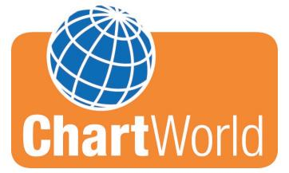

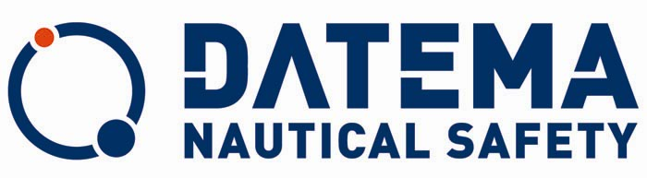







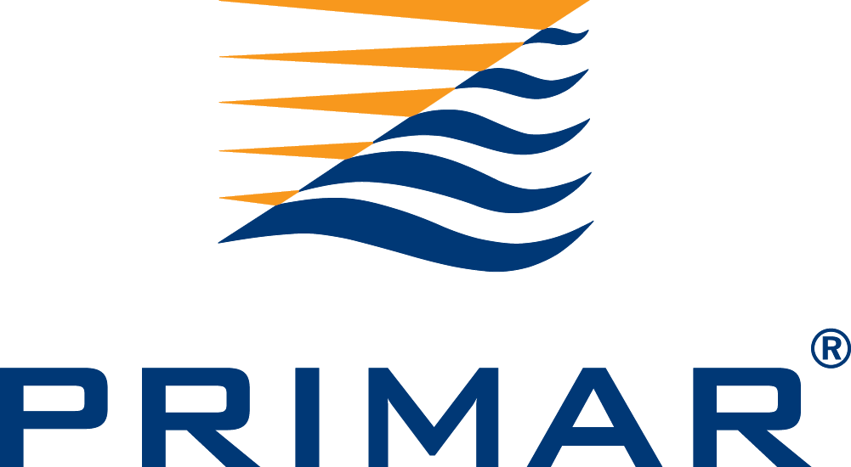



By working with these companies, IC-ENC can offer the mariner a choice between different styles of services each incorporating the wide range of ENCs, and which are available through the variety of well known international distribution outlets. IC-ENC acts as single point of supply offering consistent terms that give VARs the flexibility to offer a range of integrated services to meet the needs of the international mariner.

With the VAR model of distribution, IC-ENC members avoid:

* Cost of developing and marketing their own services for global distribution
* Appointing and managing an extensive distributor network with the associated commercial and legal requirements
* Need for complex and expensive service delivery systems

IC-ENC members supply their ENCs to IC-ENC on a *non-exclusive* basis, and so each member can also, if they choose, distribute to other organisations, local markets, their Navy and so on.

**How are the ENC’s protected?**

IC-ENC supplies the ENC data to the VARs without encryption, but by using a secure file transfer process. This is to give the VARs maximum flexibility regarding service provision, permit generation and so on. The VARs then manage the ENC encryption process themselves, and from this point onwards distribution is of encrypted ENCs, using the IHO S-63 Data Protection standard. Prior to appointment, each VAR must demonstrate its encryption process, to the satisfaction of IC-ENC.

**What services do the VARs/distributors benefit from?**

In order to allow a wide range of service developments and to encourage innovation, IC-ENC simply supplies each VAR with a basic exchange set of the ENC files for the week, and a central text document listing the IC-ENC cells now available, plus details of the weekly release. The VARs then integrate this new data into their services (which will also contain data from other sources) and make it available via their own catalogues and ordering systems and their own international network of distributors.

**How much does it cost to join IC-ENC?**

There is no annual fee or standing charge to be a member. IC-ENC is financed from the sale of ENC, by retaining a fixed fee for each sale made (see ‘How is IC-ENC funded?’ below).

**How much does IC-ENC cost to operate annually?**

IC-ENC’s financial strategy is to keep costs as low as reasonably practical. This gives maximum return to the producing HOs. Annual operating costs are declared in three strands; staff costs, Information Technology costs, and Office costs. Annual operating costs are in the region of USD 1m.

**How is IC-ENC funded?**

IC-ENC is a low cost, ‘not for profit’ organisation which is financed out of ENC sales. Its costs are recovered by retaining a ‘fixed fee’ per sale of each ENC made by the VARs. The fixed fee amount is determined by the Steering Committee, and is set to a value expected to cover the forecast cost base, plus any changes to the services provided, and provide a contingency for unplanned operational expenditure. Once the fixed fee amount is agreed, each member is then free to set its own wholesale ENC price. This way, each HO knows for certain how much revenue it will receive for each ENC sold.

Each IC-ENC member is required to set its own wholesale price for its ENCs, which remain in place for one calendar year. The price is for an annual subscription for the ENC, including all updates. These prices vary due to national policies, and the average is around $10.

The IC-ENC fixed fee is $1.00 for each annual subscription for each ENC that is sold by the VARs. This has reduced from $2 during 2013. For 2015, the Steering Committee has made the decision to keep the fixed fee at $1.

An example of the pricing structure for 2014/2015 is included here:

|  |  |  |  |
| --- | --- | --- | --- |
|  | **Wholesale Price set by HO** | **IC-ENC fixed fee** | **Amount returned to HO** |
| Member HO A | $7 | $1 | $6 |
| Member HO B | $15 | $1 | $14 |

**How is the ENC revenue returned to members?**

Every quarter, the VARs report their sales to IC-ENC. These reports are collated and processed centrally, and an itemised sales report produced for each member. Each member chooses their preferred method of receiving the revenue owed to them; by bank transfer, invoice, or cheque. These payments are made on a quarterly or an annual basis, again at the request of the member.

**How does an HO join IC-ENC?**

An HO joins IC-ENC through a Bilateral Arrangement with one of the host HOs (AHS or UKHO). This ensures the relationship is at a government-to-government level, which brings many advantages. However, the joint signing of a Bilateral Arrangement between two HOs can be a lengthy process, and this can introduce a delay in the issuing of ENC coverage to the mariner.

To address this, IC-ENC has developed the *Statement of Intent to Join* document (included at Annex A). The signatories to this document are the IC-ENC Chairman and the interested HO; usually the Director or Hydrographer of the organisation. Once this is achieved, the HO will benefit from the full range of IC-ENC services while the process of the signing of the Bilateral Arrangement continues to completion. This ensures that the ENC coverage is in use as soon as possible.

**What is the relationship between IC-ENC and PRIMAR?**

Between 1998 and 2001, there was one RENC organisation, Primar, made up of 11 member nations. In 2001, these nations recognised that two distinct methods of operation were possible, each with their own benefits, leading to the formation of two separate RENC organisations; IC-ENC and Primar Stavanger (which changed back to PRIMAR in 2007).

This gave other prospective RENC members the option of joining the RENC that best suited their individual needs. During much of the 2000s, both RENC offices operated independently from each other, and at times in competition. However, over the last two years, significant developments have taken place in the working relationship between IC-ENC and PRIMAR at a political, operational and technical level.

With the full support of the existing RENC members, IC-ENC and PRIMAR are part way through a programme of work to:

* Promote closer co-operation between the two RENCs
* Harmonise RENC policies
* Increase RENC membership

The goal of the RENC-RENC co-operation programme is to improve the ENC services available through distributors and VARs to end -users. Many of the issues raised at the ECDIS Stakeholders’ Forum (see IHO CL 82/2008) are being addressed, including greater flexibility and harmonisation of licensing options, the availability of ENCs, and an agreed approach to data quality and consistency issues.

The RENC Harmonisation Sub-Group (RHSG), formed under the IHO WEND Working Group, is in place to oversee the RENC-RENC co-operation programme and to make it visible and accountable to the IHO community.

**How do I find out more?**

For further information on IC-ENC, please contact the General Manager, James Harper:

Tel: +44 (0) 1823 723 341

Email: [james.harper@ic-enc.org](mailto:james.harper@ic-enc.org)

Website: [www.ic-enc.org](http://www.ic-enc.org)

**Annex A – Statement of Intent to Join IC-ENC**

**STATEMENT OF INTENT CONCERNING COOPERATION BETWEEN**

**THE ORGANISATION NAME**

**AND**

**THE INTERNATIONAL CENTRE FOR ENCs**

The International Centre for ENCs (IC-ENC) is a Regional ENC Coordinating Centre (RENC), an organisation through which national Hydrographic Offices work together to ensure a high quality and consistent international ENC dataset.

The Organisation Name (Organisation Initials) has the responsibility and obligation to produce official ENCs.

The Organisation Name (Organisation Initials) and the International Centre for ENCs (IC-ENC) agree to cooperate on the production, validation and distribution of (Organisation Initials)’s ENCs.

This Statement of Intent recognizes that (Organisation Initials) has begun the process to become a member of IC-ENC, via a bilateral arrangement with Host Organisation Name (Host Organisation Initials).

Whilst the bilateral arrangement process is in progress, this Statement of Intent means that IC-ENC will provide Organisation Initials with:

* Support and advice on the production of ENC’s, including full access to the IC-ENC Errors Database
* An independent ENC validation service
* A route to market for its ENCs
* Sales reporting and financial settlements to Organisation Initials (where appropriate)

During this period, Organisation Initials will:

* Supply its ENCs to IC-ENC; this is on a non-exclusive basis, and so does NOT prevent Organisation Initials from supplying its ENCs to other governmental or commercial organizations, to other RENCs, or to ENC users.
* Accept IC-ENC’s core commercial and technical policies
* Be invited to participate in the IC-ENC technical and commercial working groups
* Be invited to participate in the IC-ENC Steering Committee, via observation and contribution to discussion. The aim of the Steering Committee is to reach a consensus, but in the event of a vote, only those members who are full Participants through a Bilateral Arrangement will cast a vote.

This Statement of Intent does not represent a legally binding commitment under international or national law.

In the event that Organisation Initials decides to terminate cooperation with IC-ENC, Organisation Initials and IC-ENC will work together to ensure that all existing users of Organisation Initials ‘s ENCs are not disadvantaged.

The points of contact for finalising the details of this cooperation are:

|  |  |  |
| --- | --- | --- |
| ...............................................................  Chairman of IC-ENC Steering Committee  Date......................................................... |  | ...............................................................  Head of…,  Organisation Name  Date........................................................ |